Evaluation Proposal: Restorative Justice System in Schools

Name
Institution
Date

Evaluation Proposal: Restorative Justice System in Schools
Background

General information
Education is essential for every country in boosting the economy and accelerating economic growth. Schools have been experiencing aggressive behaviours from students. Teachers play a major in the guidance and counseling of students to regulate aggressive behavior. Examples of defiant actions portrayed by students include a progressive argument with teachers. Elmurod (2021) mentioned that some students had developed hostility to their teachers in their communication and general ways of acting. Other learners deliberately get involved in activities that annoy other people, especially the students and teachers. Blaming others is among common aggressive behaviors that many students in the current days have adopted. This impacts negatively on people's mental health on who the blame falls and might lower their academic progress. At times, the students act chronically touchy or vindictive. This behavior is adopted to ensure that they evade punishment from their teachers.
The primary causes of aggressive behavior among the learners include a negative home environment. Studies have revealed that most of the students caught in aggressive actions are exposed to poor parenting styles. For instance, broken or divorced parents' families raise children with hostile behavior. Parenting styles matter a lot in the determination of the behavior of children. Strict parenting styles are discouraged in the modern era, which is among the reason’s children have developed hostility both in school, at home and in society (Elmurod, 2021). In addition, unfriendly parents' actions towards the children, like oppressing them and using extremely harsh correctional behavior, make them develop tolerance to pain and thus start having aggressive behavior. Findings depict that unfriendly relationships with peers, injustice happening in modern societies, and drug abuse contribute primarily to aggressive behaviors among children. At times, there are poor interactions between the students and teachers, a lot of pressure based on academic reasons, and the authoritative nature of teachers that accelerate the chances of learners to change and portray aggressive behaviors (Tattum & Tattum, 2017). At the high school level, boys are found to behave more aggressively than girls.
In the United States of America, educators have discovered that students portray aggressive behaviors. All the stakeholders in the education sector perceive schools as centers of academic excellence, but in recent days, worries have developed due to the aggressiveness of learners. Furthermore, lack of discipline among the students results in increased poor academic performance, increased homicide, mental health issues, and progressive rise in suicide cases (Tattum & Tattum, 2017). A couple of solutions have been initiated to eliminate the aggressive nature of learners. Some have succeeded, while others have failed—the proposed solution in adopting the restorative justice system. Lustick (2021) mentioned that vital programs are essential in reducing exclusionary discipline and narrowing the increasing incidences of aggressive behaviors.
Restorative Justice Practices (RJP) offer means for educators to control students' disruptive actions in the classrooms directly. In the past decades, RJP led to establishment of "zero tolerance" discipline policies and up-to-date emphasis and created on the necessity of following policies (Lustick, 2021). Besides, responsive restorative justice in education practices promotes the establishment of accountability, promotes social-emotional growth, and offers corrective actions taken by schools towards the students. Change in the school environment, culture, and approaches to learners' issues are used to initiate the intended transformation in student behavior.
Restorative justice is a system of justice strategies that primarily embrace mediation and agreement in correcting people. In the 20th century, teachers used oppressive means of correcting learners, with punishments being the main one. Research has opened educators understanding that subjecting learners to regular punishments results in adverse effects like dropping positive attitudes towards education and school in general. Teachers who used to punish the learners severely were perceived with negativity, which hindered effective teacher-learner relationships (Lustick, 2021). Students adopted more punitive ways while interacting with peers and even adults. The key advantage of restorative justice practices includes avoidance of punishment and embracing mediation for correcting learners.
Activities of the Restorative Justice System
The activities that restorative justice programs are involved in regarding the education sector are; repairing harms that indiscipline learners might cause. This process calls for all the primary stakeholders to be engaged in the inclusive process (Lustick, 2021). In restorative justice, the community is centrally placed in initiating discipline among learners. It is almost impossible to restore justice to the schools when the community is composed of ill-mannered people. The restorative practice holds that discipline is essential for all members of society for learners to emulate and pursue success.
Furthermore, the restorative justice approach utilizes child-centered approaches in correcting learners. The victims and the accused learners come to and solution that is agreed upon. RJ programs identify and attend to unique strengths, the demands of individual learners and interests of the learners as long as they align with the school culture. For example, some learners are continuously restless and naturally talkative. Using the RJ practices, such learners can be helped fit in fieldwork activities and, in return, get to learn and comprehend the subject matter. Another important activity that restorative justice practices address is evaluating the needs of each learner. The rule of generalization has been found to have advanced effects in solving existing education issues. Using individualized approaches helps develop underlying issues affecting each student and how they can be related to their ill behavior.
Goal of the RSJ program
Restorative justice program is scientifically applied in helping learners to improve their discipline. The program manages academic discipline by ensuring learners do their assignments at the right time. Social-emotional growth is well-established using mediation approaches and subjecting offensive learners to quality guidance and counseling. The learners are trained on better ways of managing their emotions. For example, the restorative justice program advocates for learners to take some space when offended. Some learners are forced to accept their emotions, especially mood swings and act on them to prevent establishing undesirable behaviors (Fronius et al., 2019). The activities of restorative justice programs in schools result in better conflict resolution among the learners in small groups. Peer-medicated small groups involved in talks, questioning, and airing of the existing grievances. Through these practices, discipline is assured, and learners focus more on academic growth.
Children spend a lot of time in schools, and thus it is easy to manage their discipline by making better use of restorative justice practices. The chief goals of this program are to promote accountability of students to their actions. If the students become responsible, the country will have more accountable citizens. Besides, the program focuses on competency development among the stakeholders in education (Fronius et al., 2019). As for the community, members will understand the importance of acting as role models for students to emulate their behavior. For the students, they will acknowledge the significance of being disciplined. Lastly, restorative justice programs ensure community safety by promoting the development of desirable behaviors among the community members, especially the learners.
The purpose of the restorative justice system in the education sector is to build a safe, inclusive learning environment through which learning can effectively take place. Without discipline and respect for teaching, other education cannot take place as anticipated. Learners need to be taught better ways of maintaining quality relations with their teachers. Studies have provided critical data that teacher-student relationships are essential in building positive and long-lasting implications that promote students' academic and social development. Trust is more likely to be established among these two interacting parties and promote engagement in learning, behaving better in class, and achieving academically at higher levels. In addition, a safe learning environment is key for the progress of learning. A positive classroom environment is key for improving attention, minimizing anxiety, and supporting a learning culture. Learners acquire motivation that results in wonderful learning outcomes.
The restorative justice system is purposed for establishing a caring relationship that promotes ones' commitment to achieving. A caring relationship is much seen as a mutual relationship that needs trust between both parties. The parties involve the caregiver and the other individual with underlying issues. In the therapeutic practice for the education sector, teachers are mostly the caregivers, and their actions determine how learners will react to issues. In some incidence, the learners are faced with outstanding psychological issues that need the help of psychologists. Teachers have multiple roles, including acting as problem-solvers for underlying students' issues (Fronius et al., 2019). The restorative justice system for education is necessary for promoting the success of this goal.
Another purpose of the program is to ensure that every young person is valued and affirmed. Teenagers are critical in society and play significant roles that keep society motivated—in this regard, valuing them by empowering, advising, directing and educating them to solve their outstanding issues. The program makes the young people know their worth in society. Valuing the young people motivates them to find their purpose and commit to succeed in all their activities, more so academically.
Purpose of the Evaluation
The chief purpose of this evaluation is to evaluate the Restorative Justice System (RJS) program to identify if the program would help decrease the number of aggressive behaviors portrayed by teenagers in schools, and it results in long-term positive actions, especially for the problematic students. RJS is highly ranked by researchers in establishing quality behavior among teenagers. Understanding its scope of applicability in classroom management, behavioral management, and the establishment of exemptional skills in learning is essential (Schiff, 2018). Learners with aggressive behaviors interfere with the learning environment. Problematic students are poor performing and need a lot of support from different educators to get transformed and focus on achieving. The RJS program is presented as a top solution to this issue (Schiff, 2018). However, there is a need to gather information on how the RJS operates and promotes the realization of its goals. Another critical issue is to evaluate how the program initiates and maintains long-term behavioral change among the problematic students.
As mentioned by López et al. (2018), progressive behavioral change is procedural. It takes at least a month for one to gain new traits. The RJS is involved in stimulating behavioral change among people. In the evaluation, it is essential to make effective follow-up and understand how the RJS program initiates change in actions within a short duration. Some participants can change their behavior within 18 days, while others take more than a month (López et al., 2018). In this regard, the evaluation will review the individualized differences that RJS needs to acknowledge for its success in promoting behavioral change among the learners.
The evaluation is goal-oriented. Results from the evaluation will be significant in helping different stakeholders in education, particularly teachers, parents, and administrators, decide if the program should be adopted for long-term purposes and throughout all the elementary and early classrooms. Elementary school encompasses grade 1 to grade 6, and the learners are aged approximately 6 to 11 years. This childhood stage is more essential in the determination of characters of a person in the future. It is easy to mold the behavior of children at the early stages before it becomes a habit. However, the applicability of RJS practices in the behavioral control of young children is much questionable. My evaluation will investigate the success of this program in transforming the actions of young children.
Accreditation approaches
The approaches to be utilized in the evaluation include expertise or accreditation approaches. In this evaluation approach, the primary focus will be getting the view of different experts regarding the programs. For example, the minimal Model ascertains the basic characteristics of the school and program. The Model uses numeric and regulation-based questioning. For instance, does the school have enough budget, infrastructure and necessary reserve to allow the program to run effectively? The experts will as well question the success of the RJS program in schools. Does the RJS program initiate adoption of behavioral changes among the learners? This is a possible evaluation question that can help us understand the use of RJS success for addressing aggressive behavior among learners (Souza & Rose, 2021). The content-Based Model is another expertise approach the requires strict adherence to a core curriculum. In this Model, the faculty and curriculum are analyzed. The accreditation process is made potentially fair, and the criteria are relatively easy to maintain. There are ambiguous rules applicable in the Model. For RJS, the experts evaluate how faculty values behavioral development in both curriculum and core-curriculum activities. The outcome-based Model emphasizes of core-curriculum by defining the goals of each program. However, the specific goals of the program, like RJS, are not clearly defined. For example, the accreditation, in this case, can be “to maximize the number of learners who manage to change their behavior within one month of subjection to RJS practices.” The expert’s opinions portrayed in the models are of great significance in evaluating the success of the RJS activities (Souza & Rose, 2021).
Behavioral Objectives Approach
The Behavioral Objectives Approach by Tyler is based on the fact that learning objectives have several components. The audience is centrally positioned and is much critical in determining methods of presenting the subject matter. The other critical component in Tyler’s approach is behavior. There are expectations set, and that should be achieved by the end of any program. The RJS program should have well-developed approaches for determining the levels of behavioral changes. It is important to carefully choose the most appropriate words to explain the behavior displayed by students participating in the RJS program—the language used to describe the desired behavior. For instance, the actions words used might encompass “explain” and “identify” to give a standard description of the observed behavioral change from the RJS practices initiated in solving hostile actions by the school-going adolescents. The other component is standard. It holds that the learning objectives must acknowledge what standards certain knowledge and must be achieved by the learner (Achor et al., 2021). In reflection, it should be easy to identify how the learners receive RJS practices. For example, the teacher should be able to not the percentage change in behavior under the disciplinary program. Lastly, the condition is another element that specifies the conditions under which that programs should operate. For example, “after this program, the ill-mannered learners should be able to use good communication and interact with peers with respect.” Through evaluation of the objectives, it is easy to tell if the objectives of the RJS program have been attained.
CIPP Evaluation Model
CIPP evaluation model was developed by Stufflebeam in 1983 and had four critical components; content, input, process and product (Pramono, 2021). The Model is effective in evaluating the performance of the program through summative assessment. The content in RJS programs involves mediation among peers and the strategies through which the mediation can be made effective. In the input evaluation, the plans laid down in RJS program by utilizing the critical stakeholders like teachers, faculty, and parents prove that the program is life-transforming since it is much inclusive. In the process evaluation phase, actions of the RJS program are effectively analyzed. Feedback is provided to students on the progress of their behavior and implementation of better strategies applicable in helping RJS experts to meet their goals in curbing the incidences of hostility among the learners. Product evaluation evaluates the outcomes (Pramono, 2021). For example, the impacts of RJS practices on the behaviors of young people. Based on the analysis of the RJS practices for eliminating recommendable actions, the program is proven significant in solving the behavioral concern.
Collaborative Evaluation
The education sector needs a substantial degree of collaboration among different stakeholders. Evaluators are involved in the evaluation process to determine the extent that stakeholders are willing and capable of being involved in essential practices of the program. RJS practices need services from different stakeholders, including teachers, learners, parents, the faculty and the government (Pramono, 2021). Getting involved actively in the implementation of this essential program is necessary for offering solutions to the underlying issues in the program. Collaborative evaluation in the RJS program will establish locally relevant evaluation questions, build capacity, empower the participants, and improve the program's general performance.
Evaluation Questions
This evaluation will be guided by the following questions:
- What is the impact of The Restorative Justice System on student academic success?
- To what extent has current Restorative Justice System programs in schools made an impact on student behavior?
- Has the Restorative Justice System improved relationships amongst teachers, students, and other stakeholders?
- Has the Restorative Justice System program provided strategies for teachers to create and maintain a learning environment conducive to learning?
Stakeholder Involvement
Stakeholders in the evaluation of the RJS program include teachers, students, building-level administrators, program implementors, faculty, and parents. Teachers will keep track of the program and its applicability in classroom situations. Besides, they will evaluate the infractions, attendances, and academics. They will be given monthly surveys about the level of participation, relationship increases, and feelings about the program. They will also be asked about their feelings about the program. Furthermore, the building level administrators will be responsible for tracking the progress and improvements caused by the implementation of The Restorative Justice System program (Haseski & İli̇c, 2019). They will pull behavior and attendance reports and chart things like percentages of office referrals and attendance increases. They will be responsible for implementing professional developments for teachers to ensure the program is being properly implemented for accurate data including feedback. Students and critical stakeholders in the evaluation process and their roles will include conducting regular surveys to evaluate the program. Besides, the program implementor will evaluate whether the program is achieving intended outcomes, evaluate ways to make improvements, and training personnel. The faculty, staff, and parents will provide feedback on the interview questions and come up with solutions to significant issues affecting the program.
The evaluators are expected to effectively collaborate with members of these teams in coming up with a better solution for the mitigation of underlying aggressive behaviors among the students. Through collaborative efforts, the key components of the evaluation process will be made easy. Data collection using methods like surveys and interviews in the evaluation will be prioritized and this sets up and a good foundation for providing quality answers to the research question. Besides, discussion of the results in depth will embrace stepwise examination of the possible benefits and harms of the RJS program in the schools. Communication is key for keeping the stakeholders focused on the realization of a common goal and this will be maintained using phone calls, and sending information through emails. Confidentiality will be upheld and participants will feel respected in the process. At the end of the evaluation process, stakeholders will analyze the evaluation findings, limitations, and conclusions concerning the program.
The evaluation’s main participants are children aged 18 years and below. In this regard, informing parents will be essential for the evaluation to run without multiple challenges. All the stakeholders will be informed on the reason for performing the evaluation, who will be performing the evaluation, and any other relevant data needed by the stakeholders. Participants without the consent of their parents will be termed as unqualified for the program.

Evaluation Design
Evaluation designs will use mixed methods, that is formative and summative evaluation approaches. The primary data source will include analysis of the previous year’s attendance reports, previous year’s behavior reports which include referrals and at-risk details, previous year’s universal assessment results from the students, teacher infraction logs and behavior chart logs, behavior tier data, and reports. In addition, surveys from administrators, teachers, students, faculty, and staff in collaboration with interviews from faculty, staff, parents, and program implementers will provide necessary data for the program evaluation.
Data collection is a critical step for the effective evaluation of any program (Haseski & İli̇c, 2019). In this program, data evaluation will involve Electronic Google Form Surveys especially the Likert scale. Google forms offer a fast way of creating online surveys. In the evaluation, surveys will be created and respondents invited through emails. In-person, or ZOOM, interviews are also deemed essential in the provision of relevant data. They will be utilized in the interview process in providing the most relevant data from participants. The instruments, administration procedures including time-frequency of data collection will be provided as per the research question being analyzed.
Strongly Disagree | Disagree | Neutral | Agree | Strongly Agree
1 | 2 | 3 | 4 | 6
Fig 1: Likert Scale used in data collection based on the evaluation question.
Administration Procedures
The program utilizes multiple procedures to realize its success. Two months over the summer collecting data is among the guiding procedures. This activity involves pulling initial reports, surveying and interviewing stakeholders about the current PBIS program (Kittelman et al., 2019). The facilitators acknowledge the significance of having stakeholders actively involved in the program. The plan involves three-four months of training stakeholders on the program and how to implement the policies and procedures of the RJS program in schools. Administering the initial survey to teachers, students, and administrators or training that students are another critical procedure that is geared towards improving the general performance of the learners in terms of the behavior portrayed. Data collection will be conducted twice every nine weeks, that is towards the midterm and almost at the end of the term. Administer surveys and interviews or collect behavior reports, collect attendance reports, and collect universal screening progress monitoring results are other essential procedures to be applied in the project evaluation.
Plan for Data Analysis and Expected Results
Evaluators will compile all the results from data sources and charts findings twice per month. At the end of each data collection period, data will be evaluated for effectiveness. At the very end of the data collection year, results will be compiled and evaluated for effectiveness. It is expected that at least 80% of all students will perform at or above bench level/ grade level. It is expected that by the end of the school year, at least 90% of all students will have attended school 85% of the year. Besides, it is expected that by the end of the school year, misbehavior will be seen less in the classroom and the school. Below is a question-based analysis of the RJS evaluation program.
EQ1: What is the impact of The Restorative Justice System on student academic success?
This evaluation question is focused on acknowledging the impacts of the RJS on learners’ academic progress. Evaluation of the previous years’ data on academic performance will offer a solution to this research question. This method utilizes an evaluation of formative information from both existing sources and recently collected data through interviews. Focus groups will provide the desired qualitative data from different stakeholders. In the process, the facilitators will keenly ask to listen to the responses provided by the participants. The primary expected outcomes include that RJS allows learners affected with behavioral issues to calm down and return to a normal state that facilitates maximal concentration in the learning process. This proves that restorative justice is a healthy alternative to traditional disciplinary approaches.
EQ2: To what extent has current Restorative Justice System programs in schools made an impact on student behavior?
The RJS program was implemented in the education systems to eliminate the brotula punishment approaches of correcting the student’s actions. Stakeholders in the programs were progressively questioned on their awareness of the existence of RJS practices in the education systems. This is a qualitative study question and it is closed. The answers to this question are either “yes” or “no” and this served as a starting point for evaluating the success of the program. Participants with a better understanding of RJS, especially the administrators and teachers were allowed to offer in-depth information on the success of the program in establishing the desirable learners’ behavior. Data analysis utilized transcription and coding to determine the major themes and hence come up with substantive findings. In this case, the expected outcome is that RJS programs have lowered incidences of learners’ aggressive behavior by a significant margin.
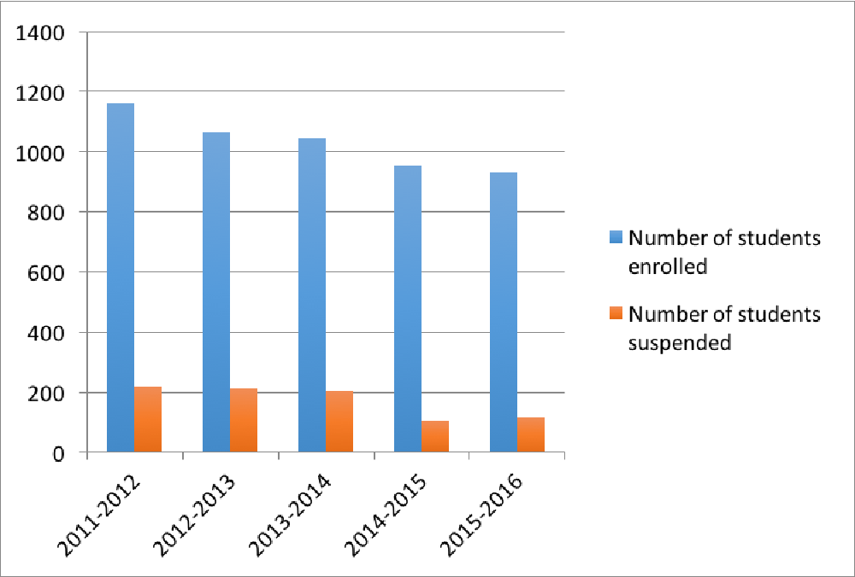
Fig 2: A graph showing numbers of students enrolled for RJS and number of students suspended progressively between 2011 and 2016.
EQ3: Has the Restorative Justice System improved relationships amongst teachers, students, and other stakeholders?
Evaluation question 3 is much relevant in the RJS program. Teachers are among the essential stakeholders in the education sector. Their roles are diverse including establishing better relations with the teachers. Data for this question is collected by the analysis of previous years’ data on RJS and the establishment of effective relations among the education stakeholders. Original data will as well be collected from the participants and they will offer a comprehensive explanation on the applicability of restorative justice in maintaining good relations among the stakeholders in schools. Triangulation of both qualitative and quantitative data will help in validating the significance of RJS practices in improving teacher-student relationships. The participants will be allowed to use case studies in explaining and defending their arguments.
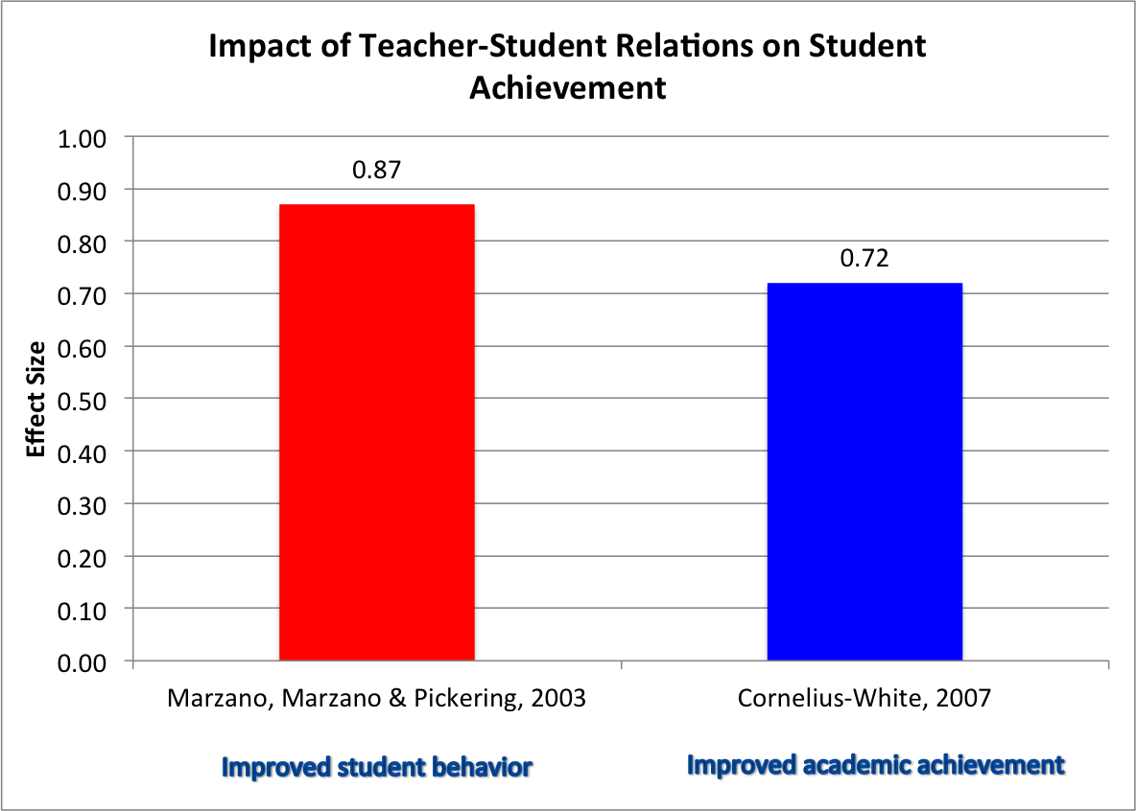
Fig 3: A graph showing the teacher-child relationship and effect on student performance
Corporal punishment is expected to be described by most participants as the method that ruins the teacher-student relationships and affects learners’ concentration in classroom activities. The implication of this is that mediation strategies are effective in building effective teacher-student relationships and promoting learning.
EQ4: Has the Restorative Justice System program provided strategies for teachers to create and maintain a learning environment conducive to learning?
Evaluation question 4 is tied to the RJS program goals of creating a conducive learning environment. The quantitative data collected regarding this question will be analyzed following the participants’ views. Descriptive approaches will be applied in helping the facilitators to understand the implications of RJS programs concerning promoting better teacher-student relationships. The strategies to be evaluated in this case include addressing the student needs, establishing a sense of order in the learning process, greeting students at the door every day, letting the students know their teacher, limiting judgment to the students, and the application of class-building games and activities by the teachers. The students will evaluate their teachers based on the above-mentioned strategies. A conducive learning environment is a key to academic success.
The Rationale for Evaluation Design
The data evaluation approach applied in the program is cost-effective. Effective researchers are expected to be as cheap as possible for manageability purposes. The evaluation approaches utilized ensure all the stakeholders are satisfied with the outcomes and gain knowledge on implementing the program. This has been illustrated by the inculcation of the expert’s opinions to determine the quality of the program and offers quick, easy, and reliable opportunities for data collection and evaluation. Using the outlined data analysis techniques, practical program evaluation will be conducted.
Potential Barriers
RJS program is essential in mitigating the increase in aggressive behaviors among the students. The program has been successfully applied in behavioral restoration at the community levels and thus its application in schools can serve a purpose in eliminating undesirable actions by learners. This paper offered a critical evaluation of Restorative Justice System practices. The evaluation is well planned and it will lead to understanding if the RJS has any significance in lowering the incidences of hostile behaviors in schools (Roney & Daftary, 2020). However, it is expected that the program will be faced with barriers that might interfere with the effectiveness of the evaluation. The potential barriers include:
- Bias
It is speculated that ex principals and teachers will not be wanting their schools and classes to look bad. There are educators with faulty believes that corporal punishments offer solutions to indiscipline issues in schools. For example, the teachers of the 20th century used punishments as corrective measures and thus do not trust the RJS practices in solving hostile behaviors among the learners.
- Incorrect implementation
The success of restorative justice in schools is based on the commitment of primary stakeholders to implement the program. Teachers need proper training to gain an understanding of the implementation time of RJS practice. In this case, the barrier to implementation is the lack of proper training for teachers to implement restorative justice practices. Society is much dynamic and teachers should train on the effective ways of program implementation. Besides, incorrect implementation involves the failure to implement the process at all (Roney & Daftary, 2020). Some project implementors are stubborn and reluctant in initiating the anticipated behavioral changes due to personal reasons or the belief that corporal punishment practices are better than RJS practices.
- Incorrect or lack of data collection
Data collection is significant in determining the progress of essential programs. Some evaluators will rush data collection regarding the RJS programs and this will translate to a lack of understanding of better implementation strategies for the program. In addition, lack of data collection will challenge the RJS program evaluation and result in a lack of evidence-based programs and hence undesirable outcomes might be attained.

References
Achor, E. E., Otor, E., & Kalu, R. (2021). Boosting Achievement of Senior Secondary Two Students in Selected Difficult Chemistry Concepts Using Assertive Questioning and Prior Knowledge of Behavioural Objectives Strategies. International Journal of Education, Learning and Development, 9(4), 9-29.
Elmurod, K. (2021). The importance of education and education in renewal of Uzbekistan. ACADEMICIA: An International Multidisciplinary Research Journal, 11(6), 135-140.
Fronius, T., Darling-Hammond, S., Persson, H., Guckenburg, S., Hurley, N., & Petrosino, A. (2019). Restorative Justice in US Schools: An Updated Research Review. WestEd.
Haseski, H. I., & İli̇c, U. (2019). An investigation of the data collection instruments developed to measure computational thinking. Informatics in Education, 18(2), 297-319.
Kittelman, A., McIntosh, K., & Hoselton, R. (2019). Adoption of PBIS within school districts. Journal of school psychology, 76, 159-167.
López, E. E., Jiménez, T. I., & Moreno, D. (2018). Aggressive behavior in adolescence as a predictor of personal, family, and school adjustment problems. Psicothema, 30(1), 66-73.
Lustick, H. (2021). “Restorative justice” or restoring order? Restorative school discipline practices in urban public schools. Urban Education, 56(8), 1269-1296.
Pramono, R. (2021). The Evaluation Of Narada Cup School Sport Program Using Cipp Evaluation Model.
Roney, M., & Daftary, A. (2020). Implementation Barriers to Restorative Approaches in K–12 Schools: An Integrative Review. School Social Work Journal, 45(1), 1-15.
Schiff, M. (2018). Can restorative justice disrupt the ‘school-to-prison pipeline?’. Contemporary Justice Review, 21(2), 121-139.
Souza, J. M., & Rose, T. A. (Eds.). (2021). Exemplars of Assessment in Higher Education: Diverse Approaches to Addressing Accreditation Standards. Stylus Publishing, LLC.
Tattum, D., & Tattum, E. (2017). Bullying: A whole-school response. In Learning—to—Behave (pp. 67-84). Routledge.

